MCES Launches Telemedicine –

“In-School” Medicine

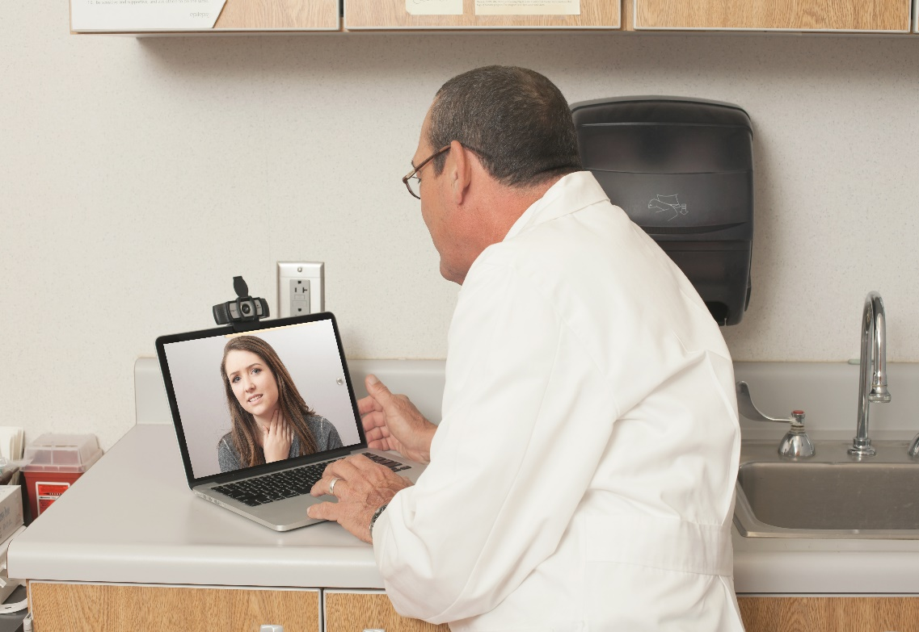 |  | - MCES Parents!  Telemedicine  allows your kids to see a Pediatrician while still in school!

- 24/7 Kid Doc’s new medical program allows parents to enroll their children to use Telemedicine to diagnose and treat their sick children, while still in school.

- Telemedicine makes healthcare more convenient, keeping kids in school and parents at work.

- With the parents’ permission, diagnoses will be made by a Pediatrician or NP thru HIPAA video conferencing & remote diagnostic equipment.

- Parents may enroll for free by:
Calling 24/7 Kid Doc 1-844-303-8006 or
by contacting your school nurse for an enrollment package.

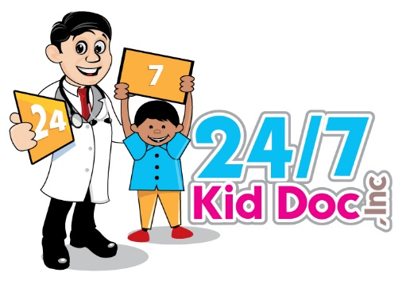
24/7 Kid Doc, Inc.

1-844-303-8006
www.247KidDoc.com

Telemedicine Process:
- Sick student is sent to the School Nurse.
- School Nurse determines if Telemedicine visit is necessary.
- Parent will be notified of sick child and asked for permission to use Telemedicine.
- School Nurse will schedule Telemedicine visit for the same day.

How do I Enroll my Child?

- Call 24/7 Kid Doc @ 1-844-303-8006
- See your School Nurse
- Request a Free Enrollment Package
- Complete the Enrollment Package
- Send package back to 24/7 Kid Doc
- School Nurse will take student’s blood pressure, pulse and temperature.
- Telemedicine Medical Provider will diagnose your child and, if necessary, send prescription to family pharmacy.
- School Nurse will call parent with follow-up instructions from the provider.
- Student will be sent back to class or wait for parent pick up.
- Student’s medical insurance is billed.

Patient/Student Enrollment

By completing this form, I consent in advance to my child having access to all-­‐available services of Telemedicine if my child remains enrolled in Montgomery County Schools. 24/7 Kid Doc, Inc. Telemedicine services include: diagnosis and treatment of common illnesses and injuries, preventive health screenings, health education and referrals.

Students must have parental permission to use Telemedicine.

Student’s Name (First, Middle, Last):

DOB: SSN: Age: Gender: M F School:

Mailing Address: City: Zip:

Primary Phone: Parent Email:

Mother/Guardian: Phone: __

Father/Guardian: Phone: __

Who does the child live with most of the time? __

In Case of Emergency, please tell us a Local Friend or Relative (not living at same address) whom we could contact.

Name: Relationship: Phone #:

Person Responsible for the Bill:

Is the Patient covered by insurance? YES or NO.

Please fill in all the following:

Primary Insurance: Name of Insurance Company: Copay Amount:

Insurance ID #: Group #: _

Name of Subscriber: DOB: SSN:

Patient’s Relationship to Subscriber: SELF SPOUSE CHILD OTHER:

Secondary Ins. Name of Insurance Company: Copay Amount:

Ins. ID #: Group #: _

Name of Subscriber: DOB: SSN:

Patient’s Relationship to Subscriber: SELF SPOUSE CHILD OTHER:

Primary Care Doctor/Clinic: _______

Pharmacy: Town: _

Patient/Student Enrollment -­‐ pg. 2
Consent Form

Child’s Name: DOB:

HIPAA/FERPA: All students have health issues that must be handled in a confidential manner. 24/7 Kid Doc will share confidential information only in the following situations:
- When the student’s education is affected
- When addressing a student’s healthcare needs
- When safety is an issue
- And other situations specified by law
For example, 24/7 Kid Doc may discuss the student’s medication and other health care needs with the appropriate staff members who will administer the student’s medication and provide care to the student while the student is at school.

_ _ _ _ _ _ _ _ _ _ _ _ _ _ _ _ _ _ _ _ _ _ _ _ _ _ _ _ _ _ _ _ _ _ _ _ _ _ _ _ _ _ _ _ _ _ _ _ _ _ _ _ _ _ _ _ _ _ _ _ _ _ _ _ _ _ _ _ _ _ _ _ _ _ _ _ _ _ _ _ _

I, the undersigned,
- give permission and consent for my child to have treatment through and by 24/7 Kid Doc. I understand the nature of this treatment, the way it is provided, and the details and limitations of Telemedicine.
- give permission for 24/7 Kid Doc to receive information from the school about my child’s healthcare history.
- agree to release all records related to this treatment to the Primary Care Provider
- agree that all I will be responsible for all costs associated with said treatment and that I will provide any insurance information as requested. All costs and fees not covered by insurance will be my responsibility.
- As Parent/Guardian of the above student, I:
  - authorize the release of any information necessary to process insurance claims for payment of benefits 24/7 Kid Doc.
  - authorize payment of benefits to 24/7 Kid Doc for services rendered.
  - have provided details of all insurance policies that cover my child.
The information above and on the proceeding page is true and complete to the best of my knowledge.

Parent/Guardian name PRINTED: Parent/Guardian SIGNATURE: Date: _____________________

No Telemedicine Services can be provided without this and the following page completed and signed.

(Next)

Patient/Student Enrollment -­‐ pg. 3
Medical History

Students must have parental permission to be seen by 24/7 Kid Doc.

________________________________ _______________________ __________________
Student’s Last Name First Middle
_________________ ____________ ___________________________
Date of Birth Gender School

Does your child have any of the following conditions or other health concerns?
o
Allergies, other than medications (such as bee stings or peanuts) – Please list
____________________________________________________________________________________ Asthma – Date of last asthma attack: ___________________
o
Seizures – Date of last seizure: ___________________
o
o
Vision Problems
Hearing Problems
o
o
Sickle Cell Anemia
Heart Problems – Please list: ________________________________________________________________
o
o
Bleeding Disorders
Orthopedic (bone or joint) Problems Anxiety/Depression
o
o
Operations and/or Hospitalizations – Dates (details below): ___________________________________
o
Diseases in Siblings
o
- If you checked ANY of the above conditions, please explain: _____________________________

_________________________________________________________________________________
_________________________________________________________________________________
Is your child on any medications?

No

Yes – Please list: ___________________________________________________________________

Is your child allergic to any medications?

No

Yes – Please list: ___________________________________________________________________

In signing this form, I am stating the following:
  - The information that I have provided is accurate and up-to-date.
  - I will update MY Health-e-Schools with any changes as soon as possible.

__________________________________________________ _________________
Parent/Guardian Signature Date

